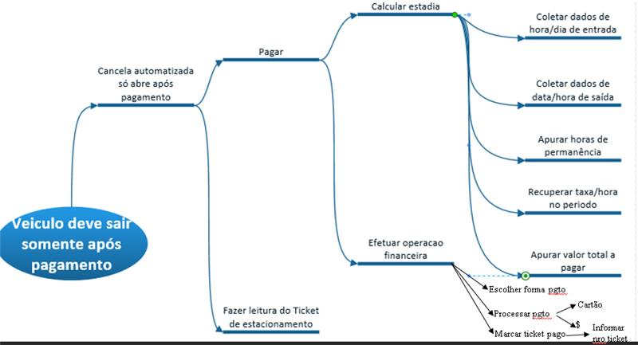<https://whimsical.com/entrada-do-estacionamento-FyhmJZpg1AexSUqT6DPxpL>

